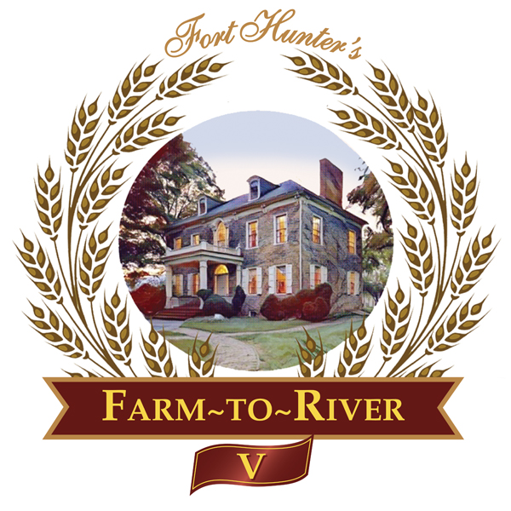

May 12, 2022

Dear Fort Hunter Patron,

The Friends of Fort Hunter invite your participation as a Patron in their much-anticipated annual fundraiser, Farm-to-River V on Sunday, August 14, 2022, at the Fort Hunter Mansion on the Fort Hunter Park grounds. Please join us this year as we note the Fort Hunter connection to the Gilded Age.

On the front lawn of the Fort Hunter Mansion as the warm summer day winds down, attendees will enjoy locally sourced, homemade dinner offerings, along with local brews, wines, and live acoustic music – a Fort Hunter innovation we call our Farm-to-River experience..

The garden party begins at 4:30 p.m. for our Sponsors and Patrons with seasonal delicacies and signature drinks enjoyed along the river. Dinner follows at 6 p.m.

Our generous Patrons provide continued investment in the fabric of Fort Hunter Mansion and Park. Our park and programming are more popular than ever, and our donors deserve our thanks and recognition of their contributions to our success.

Please join our celebration as a Reily, McAllister or Hunter Patron. Our Patrons are recognized with a prominent listing in the formal invitation, the evening program, and in The Chronicler, the Friends of Fort Hunter newsletter. Kindly RSVP using the enclosed Patron Response Form by July 1, 2022, to ensure your listing is placed in our printed materials. We will also honor requests to remain anonymous.

Event sponsorships are also available. For offer details, please visit our website https://forthunter.org/events/farm-to-river-5/.

On behalf of the Friends of Fort Hunter, we are most grateful for your steadfast and generous support, and we look forward to sharing our goals and celebrating our successes with you in August at this fun and localized twist on a farm-to-river experience.

Respectfully,
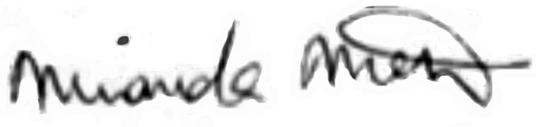
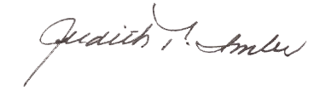
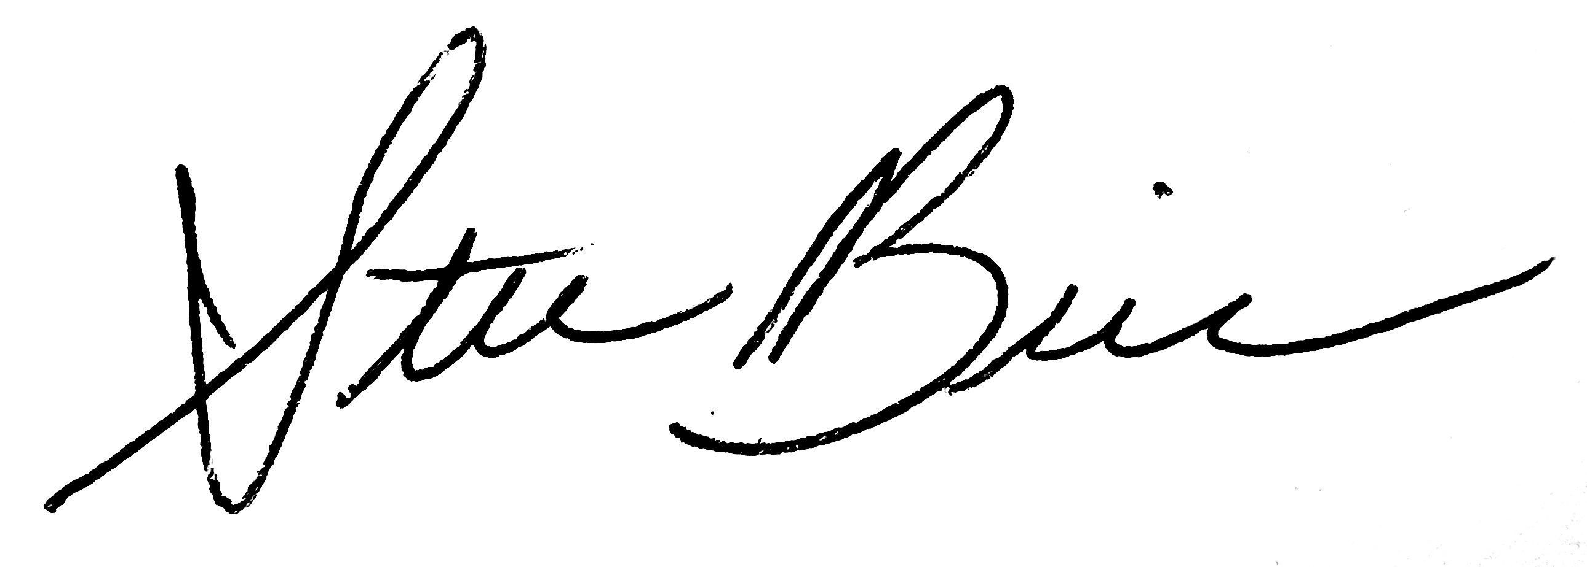

Miranda Metz Steve Brindle Judith Imler
Event Co-Chair Event Co-Chair Honorary Co-Chair

A fundraising event of The Friends of Fort Hunter Sunday, August 14, 2022

Name__________________________________________________________________

Address_________________________________________________________________

Phone _________________________Email____________________________________

Circle Chosen Sponsor or Patron Level Per Options Below:

Reily Patron_____________________ 2 Tickets $1000.00
Reily Patron_____________________ Non-Attending $500.00
McAllister Patron_________________ 2 Tickets $500.00
McAllister Patron_________________ Non-Attending $250.00
Hunter Patron____________________ 2 Tickets $300.00
Hunter Patron____________________ 1 Ticket $150.00

Co-Brand Sponsors_______________ 8 Tickets $5,000
Table Station Sponsors____________ 6 Tickets $2,500
General Sponsors_________________ 4 Tickets $1,500

For complete details on Sponsorship offerings, please visit https://forthunter.org/events/farm-to-river-5/

Total Enclosed $__________ Please make checks payable to: The Friends of Fort Hunter

Or

Visa / MasterCard $________ Card No. _____________________________________________

Exp. _________ 3 digit CVC # (on reverse of card)__________ Please Note: Credit Card Fees will apply.

Signature ___________________________________________
Please respond by July 1, 2022, to ensure listing in the formal invitation as an event patron. Please return this form and your check or payment information to:
Friends of Fort Hunter, 5300 N. Front Street, Harrisburg, PA 17110.

Questions, please call: 717-599-5188, ext 2116 Fax: 717-599-5397
Attendance grants DCPR permission to use photos taken at the event in future promotional materials.

