2022 Event
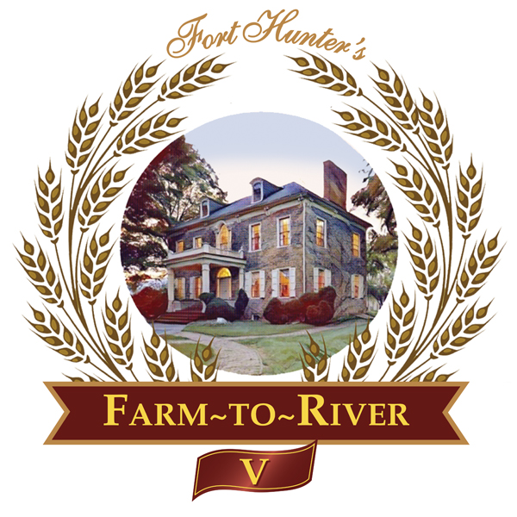
Sponsorship Information

Sunday, August 14, 2022, beginning at 4:30 p.m.

Annual Fundraiser for Fort Hunter Park and Mansion

Brought to you by Friends of Fort Hunter

Farm-To-River Overview
The 2022 Friends of Fort Hunter annual fundraising event is surrounded by history. Join us this year as we note the Fort Hunter connection to the Gilded Age. On the front lawn of the Fort Hunter Mansion, as the warm summer day winds down, our guests will enjoy locally sourced and crafted dinner offerings, accompanied with local brews, wines and live acoustic music – a Fort Hunter innovation we call our Farm-to-River experience. The garden party begins at 4:30 p.m. for our Sponsors and Patrons with seasonal delicacies and signature drinks enjoyed along the river. Dinner follows at 6 p.m.

Sponsorship Opportunities
$5,000 Co-Brand Sponsors (2)
- 8 patron event tickets.
- Name/logo with link on all event promotional materials used in advance of, and at the event (approximately 40,000 impressions). *example attached
- Name/logo included at top of event invitation (7,400 unique emails, 421 postage), postcard and website.
- Opportunity to supply items for exclusive event patron SWAG bag.
- Name/logo included in the Fort Hunter quarterly newsletter to approximately 260 residents.
- 8 tickets to tour Fort Hunter Mansion.
$2,500 Table Station Sponsors (10)
- 6 patron event tickets.
- Name/logo on forthunter.org (linkable with approximately 4,000 monthly impressions) and a dinner table station at the event.
- Opportunity to supply items for general admission SWAG bag.
- Name/logo included in the Fort Hunter quarterly newsletter to approximately 260 residents.
- 6 tickets to tour Fort Hunter Mansion.
$1,500 General Sponsors (Unlimited)
- 4 patron tickets.
- Name/logo in the Fort Hunter quarterly newsletter to approximately 260 residents.
- 4 tickets to tour Fort Hunter Mansion.

Patron tickets begin at $150.

Thank You for Your Consideration!
Steve Brindle and Allen Lengle
Friends of Fort Hunter Board Members
s_brindle@ml.com and awlengle@aol.com.

A fundraising event of The Friends of Fort Hunter Sunday, August 14, 2022

Name__________________________________________________________________

Company Name__________________________________________________________

Address_________________________________________________________________

Phone _________________________Email____________________________________

Circle Chosen Sponsor Level Per Options Below:

Co-Brand Sponsors_________________ 8 Tickets $5,000
(2 available)

Table Station Sponsors______________ 6 Tickets $2,500
(10 available)

General Sponsors___________________ 4 Tickets $1,500
(Unlimited)

For complete details on Sponsorship offerings, please visit https://forthunter.org/events/farm-to-river-5/
Total Enclosed $__________ Please make checks payable to: The Friends of Fort Hunter

Or

Visa / MasterCard $__________ Card No. ___________________________________________

Exp. ____________ 3 digit CVC # (on reverse of card)__________ Please Note: Credit Card Fees will apply.

Signature _____________________________________________
Please respond by July 1, 2022, to ensure listing in the formal invitation as an event Sponsor. Please return this form and your check or payment information to:
Friends of Fort Hunter, 5300 N. Front Street, Harrisburg, PA 17110.

Questions, please call: 717-599-5188, ext 2116 Fax: 717-599-5397
Attendance grants DCPR permission to use photos taken at the event in future promotional materials.

